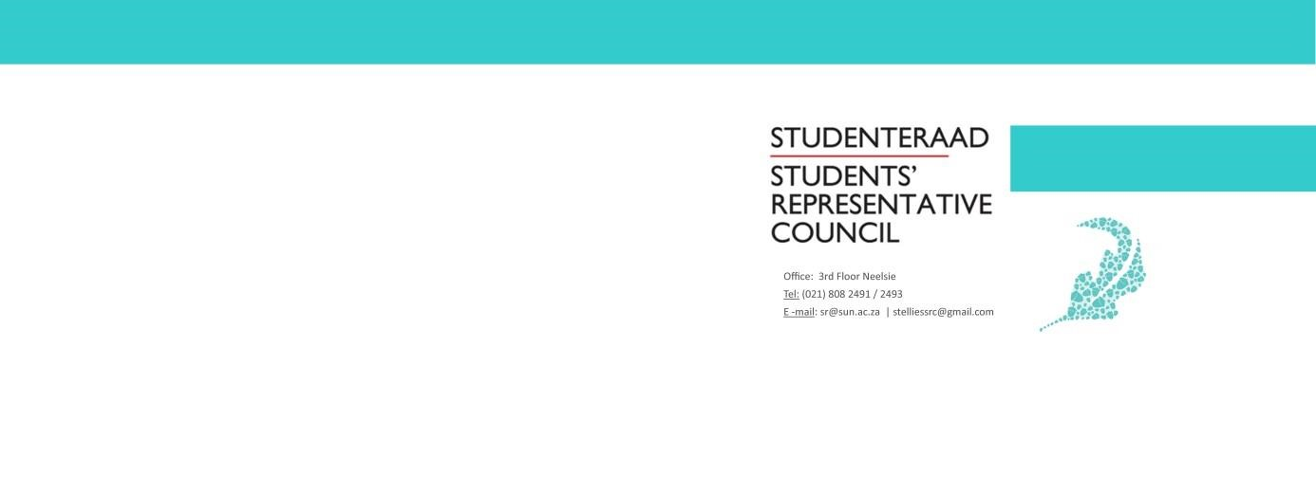
AGENDA
Student Representative Council Meeting
Date: 5 June 2020
Time: 17:15 - 18:30
Venue: SRC 2019/2020 MS Teams

- Welcoming Lewis
- Attendance
- Approval of previous meetings minutes
- Voting
  - SRC jurisdiction constitutional amendments
    - Presented by Societies Council
    - Presented by Prim Committee chair
  - SRC support for other amendments
- Closing Lewis

